UNIT 3 - UNIFORMLY ACCELERATING

PARTICLE MODEL

# INSTRUCTIONAL GOALS

**1. Concepts of acceleration, average vs instantaneous velocity**

Contrast graphs of objects undergoing constant velocity and constant acceleration

Define instantaneous velocity (slope of tangent to curve in **x** vs **t** graph)

Distinguish between instantaneous and average velocity

Define acceleration, including its vector nature

Motion map now includes acceleration vectors

**2. Multiple representations (graphical, algebraic, diagrammatic)**

Introduce stack of kinematic curves

position vs. time (slope of tangent = instantaneous velocity)

velocity vs. time (slope = acceleration, area under curve = change in position)

acceleration vs. time (area under curve = change in velocity)

Relate various expressions

**3. Uniformly Accelerating Particle model**

Domain and kinematical properties

Derive the following relationships from **x** vs t and **v** vs t graphs

$\overset{⃑}{\overline{a}}= \frac{Δ\overset{⃑}{v}}{Δt}$ Eq. 1 definition of average acceleration

$\overset{⃑}{v_{f}}=\overset{⃑}{v_{o}}+\overset{⃑}{a}t$ Eq. 2 linear equation for a **v**-t graph

$\overset{⃑}{v_{f}}=\overset{⃑}{v_{o}}+\overset{⃑}{a}Δt$ Eq. 3 generalized equation for any ti to tf interval

$\overset{⃑}{x_{f}}=\overset{⃑}{x_{o}}+\overset{⃑}{v_{o}}t+\frac{1}{2}\overset{⃑}{a}t^{2}$ Eq. 4 parabolic equation for an **x**-t graph

$\overset{⃑}{x_{f}}=\overset{⃑}{x_{o}}+\overset{⃑}{v_{o}}Δt+\frac{1}{2}\overset{⃑}{a}{(Δt)}^{2}$ Eq. 5 generalized equation for any ti to tf interval

${\overset{⃑}{v_{f}}}^{2}={\overset{⃑}{v_{o}}}^{2}+2\overset{⃑}{a}Δ\overset{⃑}{x}$ Eq. 6 algebraic combination of equations 3 and 5

**4. Analysis of free fall**

**5. Software** *Pyret Programming Language* (Found at: code.pyret.org) *requires a Google acct. to save

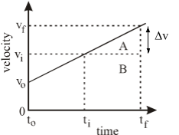**Teacher Background**

Using the graph to the left, we will look at how to build the value for vf.

vf = vi + ∆v

From analyzing the slope of the velocity graph earlier we know:

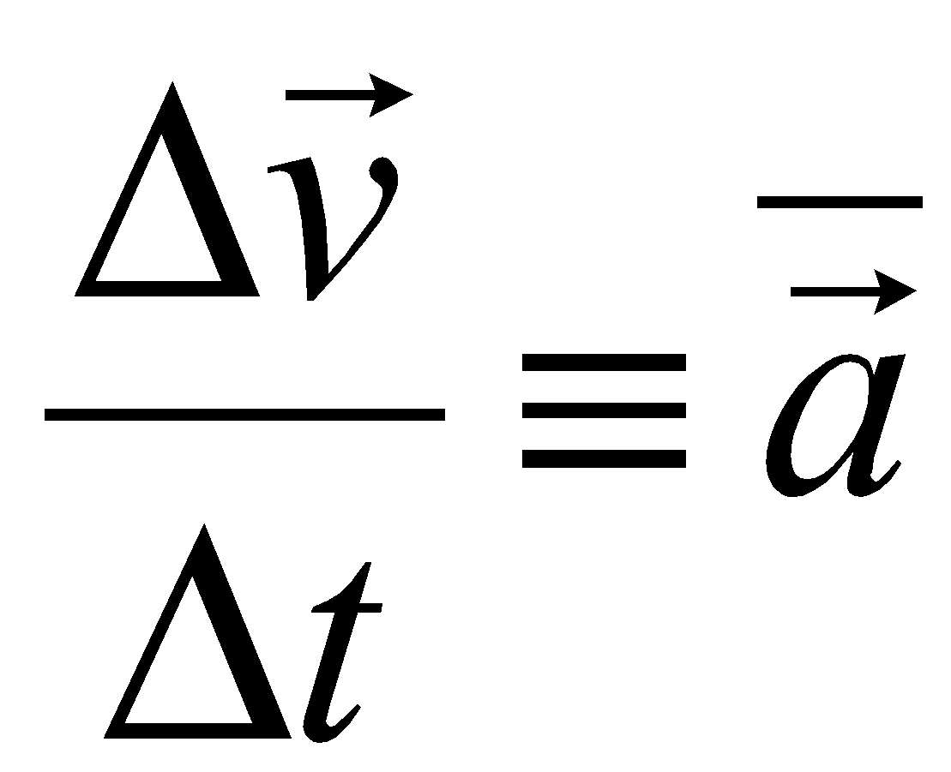

∆v = a * ∆t

So, vf = vi + (a * ∆t)

*Please note: This method for building ‘next-v’ or vf as we often refer to it, is identical to the way that ‘next-x’ or xf was built up in the Constant Velocity Unit.*

The displacement of a uniformly accelerating object is equivalent to the area under the *v-t* graph. In this situation, we are interested in the displacement during the time interval ti to tf

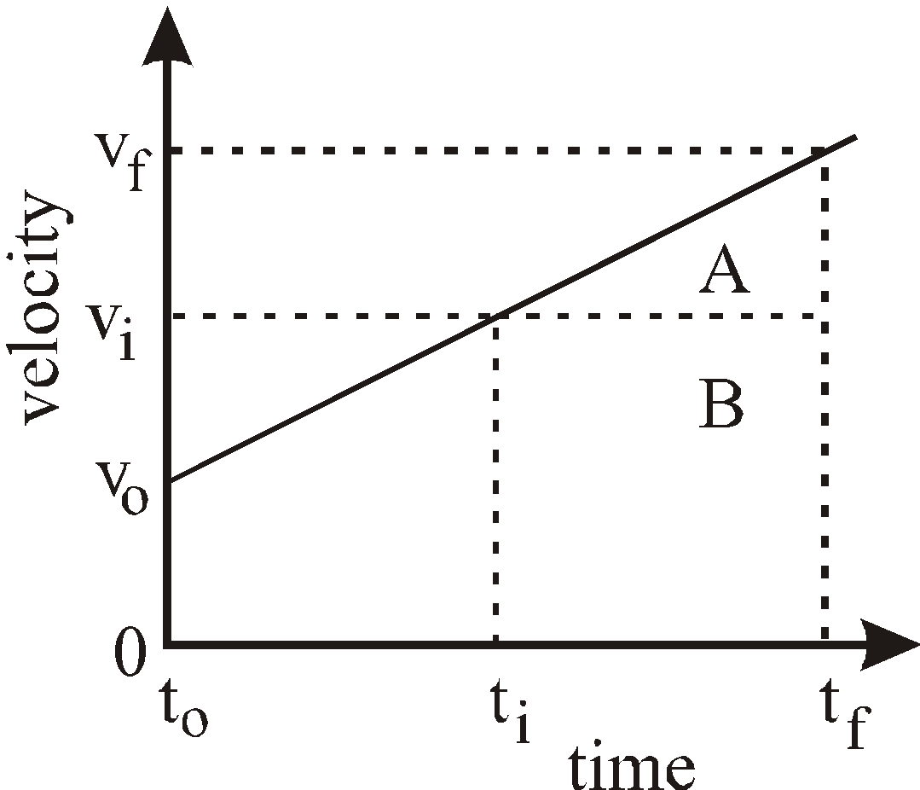

Area of region A:

1/2 *height x base* area of a triangle

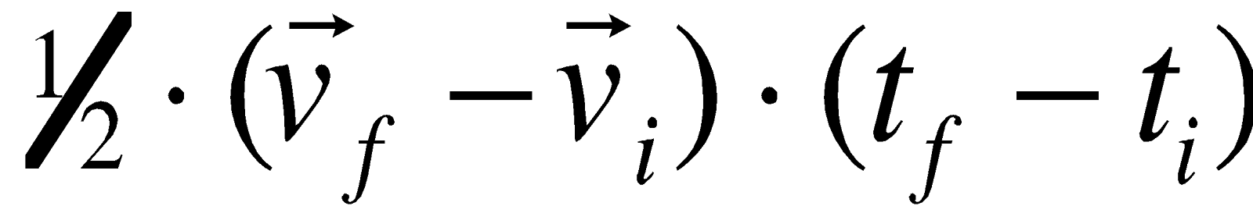

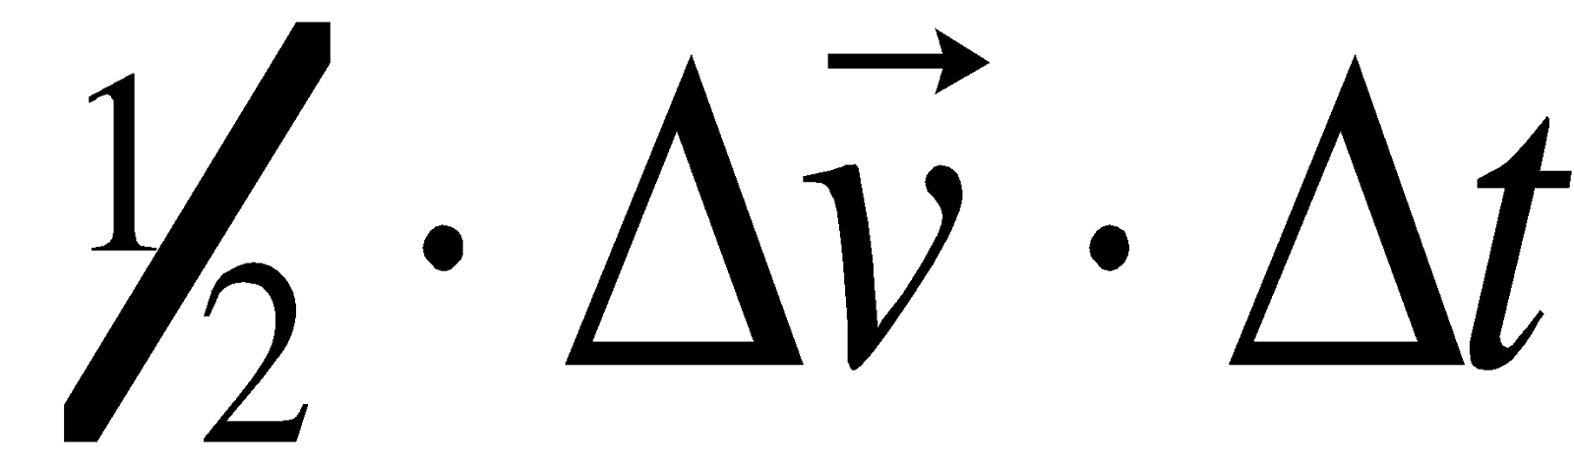

For $Δ\overset{⃑}{v}$ substitute: $\overset{⃑}{a}Δt$,

Which produces this: 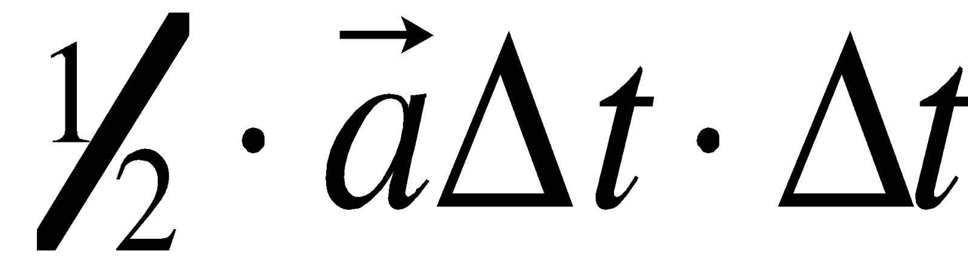

The total displacement is equal to A + B.

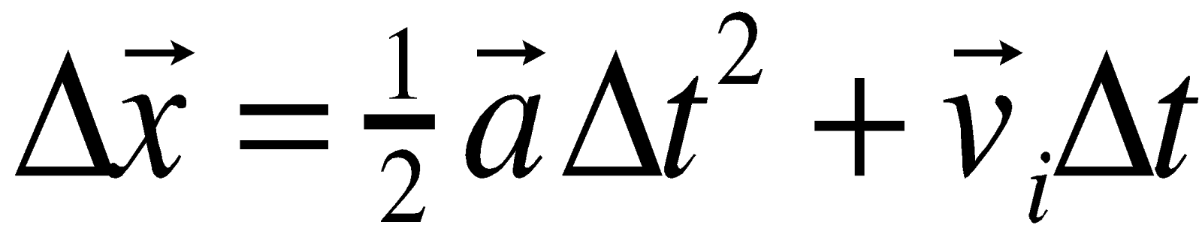

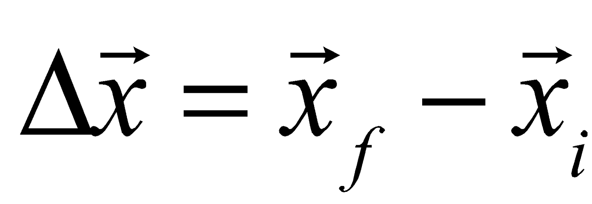

Because this becomes

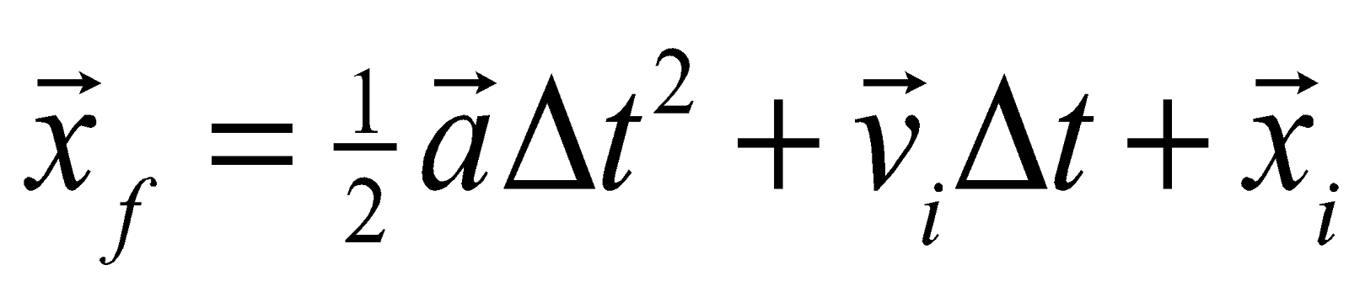

Area of region B

*length x width* area of a rectangle

The velocity at the horizontal axis is zero, so:

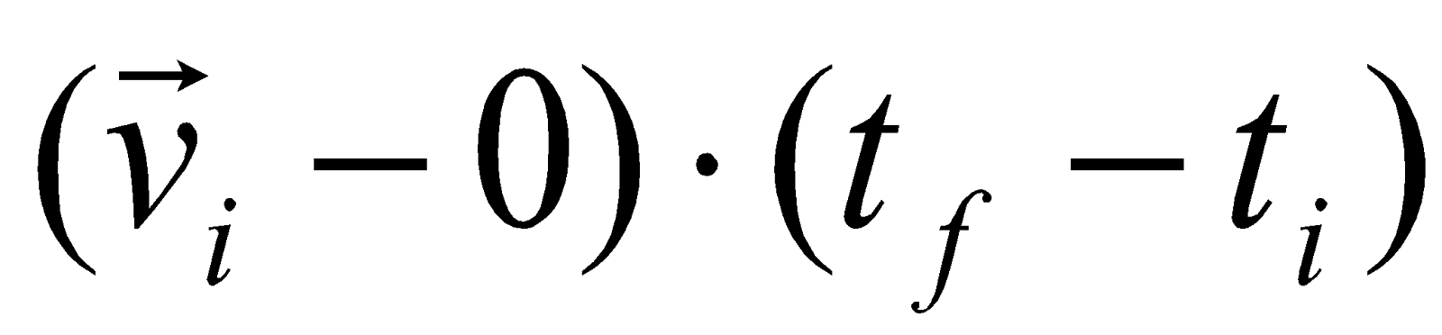 = 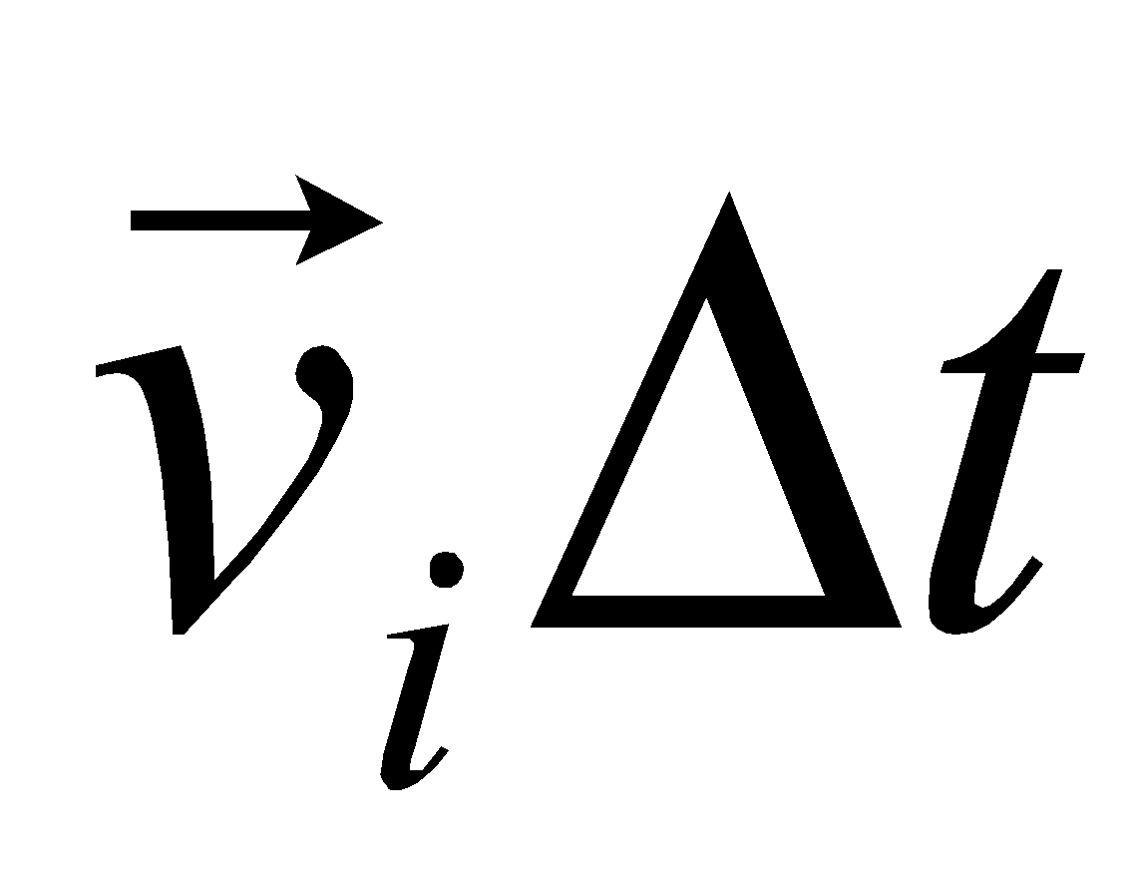

# SCOPE AND SEQUENCE

1. **Unit Primer:** Contrast fast and slow constant velocity motion

Student whiteboard motion maps, position-time graphs and velocity-time graphs

1. **Lab: Inclined Rail Motion**

Develop the velocity-time graph as a linear rather than constant relationship.

Post-lab: Use tangents to the x-t graph curve to create a v-t graph and define instantaneous velocity.

1. **Worksheet 1a, 1b, and 1c**

Students will investigate how average velocity over a small time interval can be used to approximate the instantaneous velocity and how instantaneous velocity is the tangent of the position versustime graph.

1. **Lab Extension – Speeding up and Slowing down**

Motion maps – focus on acceleration and velocity directions as it relates to speeding up vs. slowing down

Analyze area under v-t graph to develop remaining mathematical kinematic expressions.

1. **Activity 1 – Determining displacement for a non-constant velocity**

Students will analyze the area under the velocity graph based on rectangles of various heights based on the ‘v’, ‘next-v’ and ‘v-avg’.

1. **Pyret Connection…** can we model ‘speeding up’ or ‘slowing down’ motion on Pyret?
2. **Post-Lab Analysis**

Develop Equations 3, 4 and 5.

1. **Quiz 1 – qualitative interpretation of graphs**
2. **Worksheet 2 – Highway Hazards**

Students use area under a velocity-time graph to solve highway problems.

1. **Activity 2 – Miniature golf**

Students will practice golfing on different surfaces and attempt to make a hole in one. Students will then be able to determine which surface had the longest grass.

1. **Worksheet 3 – Constant Acceleration problem solving**

Standard kinematics problem set.

1. **Quiz 2 – solving problems with velocity versus time graphs**
2. **Lab 2 - Free Fall (Optional activity) -**
3. **Worksheet 4 - Free Fall practice (Optional activity) -**
4. **Practicum sim**
5. **Worksheet Review**
6. **Test**

# 1 – Unit Primer

**Instruction Goal:** Tie Unit 2 concepts together and get students focused on “Fast” vs. “Slow” motion to prepare for Accelerated Motion.

**Set-up:** Have a fast constant velocity car travelling parallel to a slow constant velocity car.

**Focus Question:** How does the representation for fast constant velocity car’s motion differ from a slow constant velocity car’s motion on a:

* MOTION MAP?
* POSITION-TIME GRAPH?
* VELOCITY-TIME GRAPH?

**Highlight points:**

* Students should recognize on the motion map, that the dots are wider spaced on the faster car than the slower car, and that the velocity vectors are longer for the faster car than for the slower car.
* Students should recognize on the position-time graph, that the slope of the fast car is steeper than the slope of the slow car.
* Students should recognize on the velocity-time graph, that the value of the fast car is higher than the value of the slow car.

# 2 – Inclined Rail Motion

## **Apparatus**

High Tech

PASCO/Vernier cart

PASCO/Vernier motion sensor

Cart Track/Ramp

Computer/LabQuest

## **Pre-lab discussion**

* Let cart roll down an inclined rail and ask students for observations. Record all observations. *To proceed, they must mention something to the effect that the cart* ***speeds up*** *as it rolls down.*
* To obtain a finer description, ask students which observations are measurable. Make sure they include the observation that the cart speeds up as it rolls down the rail. *(Do not let them state the ball accelerates since we have NOT defined acceleration yet!)*
* Ask them how they can measure speed directly. Lead them to the conclusion that they cannot, but that we do have a tool that we have used to give us that data.

**Focus Question:**If the car is speeding up as we observe, then what do we predict the motion map, position-time graph and velocity-time graph look like?

Have students work in their groups to offer up their predictions. As students may be reticent to share their thoughts… draw their attention back to the Primer… having a ‘slow’ car at the beginning of the motion… and a ‘fast’ car at the end of the motion.

**Procedure:**

* The motion sensor should be set at the top of the ramp.
* The motion sensor should be ‘zeroed’ at the position the cart will be released from. (Mark this spot)
* The computer should display both the Position-time graph AND the velocity-time graph.
* Release the car at the same time the motion sensor begins to collect data (get it as close as you can).

**Post-lab discussion:**   
Whiteboard the position-time graph and velocity-time graph.

**Focus questions:**

* How does each graph illustrate 'speeding up'?
* How are the graphs related to one another?

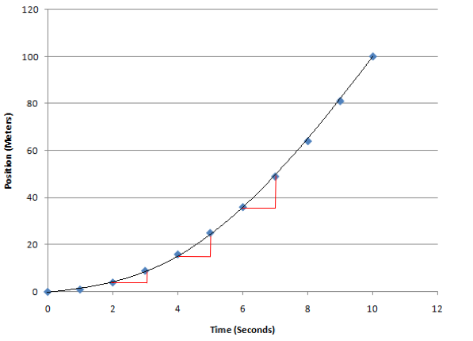Focus the whiteboard discussion on their experimental procedure and the verbal interpretation of the parabolic x-t graph. Students should be able to describe that the displacement during each time interval increases over the previous time interval. Since the object travels greater distances in each successive time interval, the velocity is increasing.

*Please note the increasing vertical part of the triangle in successive seconds. The vertical portion of the triangle represents the position change of the cart.*

Also, focus attention that the increase in that same vertical side of the triangle indicates the SLOPE increasing from one interval to the next, indicating the velocity is increasing (as illustrated by the velocity graph) as time continues to move forward.

**Post-lab Analysis:**

Students should be able to use the graph given by the motion sensor to evaluate the linear graph produced. A plot of instantaneous velocity (v, instead of v-bar) vs time should yield a straight line.

v

t

**v**

**t**

The slope of this line is:

$\frac{Δ\overset{⃑}{v}}{Δt}=\overset{⃑}{a}$. *(Equation 1)*

That is, the change in velocity during a given time interval is defined to be the *average acceleration*.

The equation for the line can be written as:

$\overset{⃑}{v}= \overset{⃑}{a}t+ \overset{⃑}{v_{o}}$*(Equation 2)*

where $\overset{⃑}{v_{o}}$ is the y-intercept and ***t*** is measured from time t = 0 seconds.

**Post-lab Analysis 2:**

Students should be able to use the graph given by the motion sensor to evaluate the parabolic graph produced. A plot of instantaneous velocity (v, instead of v-bar) vs time should yield a straight line.

The slope of this line is continuously increasing.

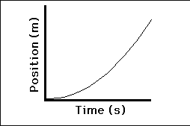

Looking at this graph with the “handy dandy slope indicator tool” (aka, whiteboard marker), have students demonstrate the changing slope.

**Focus question(s): How does *this graph* show the cart speeding up? How does *this graph* help us build the velocity graph we analyzed previously?**

This activity leads directly into Worksheet 1a, 1b, and 1c.

|  |  |
| --- | --- |
| *t* |  |
| 1. (s) | 1. (cm) |
| 0.0 | 0.0 |
| 1.0 | 5.0 |
| 2.0 | 20.0 |
| 3.0 | 45.0 |
| 4.0 | 80.0 |
| 5.0 | 125.0 |
| 6.0 | 180.0 |

# 3 – Worksheet 1a, 1b, and 1c.

**Worksheet 1a – Instructional Goal** – Students are directed to investigate the average velocity for the full motion, then for increasingly smaller steps. The students will be directed towards the ‘Mid-point’ rule. **Mid-point Rule:** for a position-time graph, the velocity at the mid-point can be approximated by finding the ‘average velocity’ for the time just before the mid-point, and the time just after the mid-point.

Using the data from Worksheet 1a:

The velocity at t = 1.0 seconds can be found by finding the slope between t = 0.0 seconds to t = 2.0 seconds.

$\frac{20.0 cm-0.0 cm}{2.0 s- 0.0 s}=v\left(1.0 s\right)$ = $\frac{20 cm}{2 s}=10 cm/s$

$\frac{80.0 cm-20.0 cm}{4.0 s- 2.0 s}=v\left(3.0 s\right)$ = $\frac{60 cm}{2 s}=30 cm/s$

**Worksheet 1b – Instructional Goal –** Students are directed to draw the average velocity chords for each second from 1.0 to 5.0 seconds. This will allow the students to build their own velocity versus time graph, based on the data provided.

*Focus attention to the fact that the slope of the TANGENT line to the curve at any given clock reading, is the SAME as the slope of the chord drawn for each mid-point.*

**Worksheet 1c – Instructional Goal –** Students are directed to take the average velocity chords and the slope determined to make a velocity-time graph that matches the position-time graph.

***BIG IDEA:***

*The average velocity approaches the instantaneous as the time interval shrinks to 0.*

# 4 – Lab Extension: Speeding Up, Slowing Down

## Apparatus

Motion detector-interface-computer

Ramp

Pasco/Vernier cart and track.

## Pre-lab discussion

Make sure students understand the format of the lab.

They are to observe the motion ***and then*** draw a motion map and predicted graphs. Then the students check their graph predictions utilizing the motion detector.

It may be helpful to show students how to resize the graph axes so students can focus on the relevant portions of the graph. Analysis should focus on the region of the graph in which the cart is coasting and not on initial pushes or final stops.

## Lab-performance notes

Perform the lab ahead of time and create a template file the students can use. The template should display x-t, v-t and a-t graphs each with appropriately scaled axes for your situation.

Situation 6 requires a separate template where the zero position is in the middle of the track. This forces students to confront the fact that the sign of the change in position, not position itself, determines the sign of the velocity.

## Post-lab discussion

Use the whiteboard session to reinforce connections between the actual motion, the description of the motion, the motion map and the x-t, v-t and a-t graphs.

It may be helpful to refer to a pencil as a “slope indicator” and have students hold the center of the pencil tangent to various places on the curve. The slope of the pencil is the instantaneous velocity on the x-t graph, and and the instantaneous acceleration on a v-t graph. Moving the pencil along the curve on the graph and observing how the slope of the tangent changes can help students to see how the velocity or acceleration changes.



Questions on the relations between graphs can be based on the following summary from the PSSC text:

Motion maps – focus on acceleration and vectors directions and speeding up vs. slowing down

See also: 99_Acceleration color toolkit.

# 

# 5 – Activity 1 – Determining displacement for a non-constant velocity

Focus Question: In the previous unit, we programmed “next-x(x)” as:

next(x): x + (v * delta-t)

But, WHICH velocity should we use? Should we use “v”, “next-v” or some *other* v?

**Background** **Concepts**

From Worksheet 1a-c, we developed the idea that average velocity of a time interval is the instantaneous velocity at the midpoint of a time interval. After the differential function next-v is developed for uniform acceleration a discussion of how good of an approximation this makes is developed using the area method for finding displacement. 

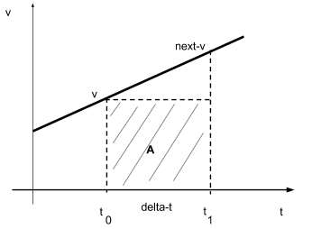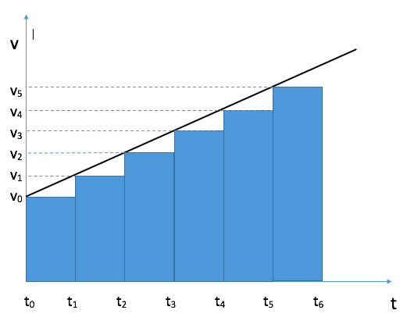The Pyret function “*next-x”* consumes a position and returns a new position.   
It was defined as **x + (v * dt)** where x is the current position and v * dt is the displacement that will be added to the get the next *position*. This displacement *(represented by area A)* is added to the object’s position at t 0. This will undershoot the object’s position at t 1.

Looking at an entire graph, and looking at use the ‘v’ value, you can see that the area of the graph is dramatically smaller than the whole space *should* be. Each step in the process is too small compared to the area it should be, and we see that area below the graph is a triangle… and that is the deficit for each position for each time interval.

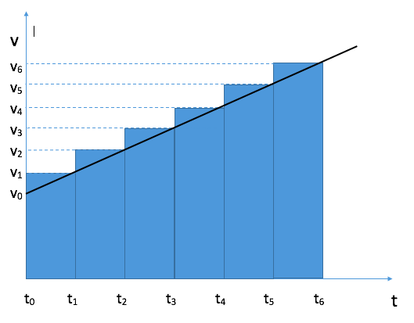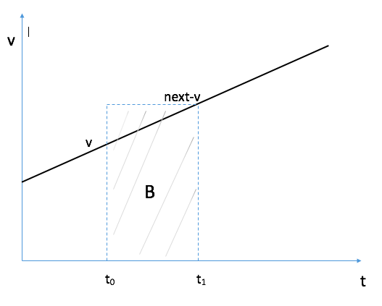The function *next-v* consumes a velocity and returns a new velocity. It is defined as v + (a * dt) where v is the current velocity and (a * dt) is the change in velocity that will be added to the previous velocity. We embed this function into next-x to compute for the displacement that will be added to the get the next *position*. This displacement (represented by area B) is added to the object’s position at t 0. This will overshoot the object’s position at t 1.

If we use the ‘next-v’ value, looking at an entire graph, you can see that the area of the graph is dramatically larger than the whole space *should* be. Each step in the process is too large compared to the area it should be, and we see that area above the graph is a triangle… and that is the extra step each time interval.

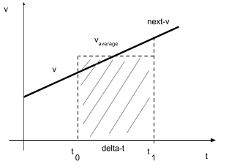

Using *next-x* and *next-v* does not accurately compute for the object’s actual displacement at t 1. The concept of average velocity should be introduced: vavg = (v + next-v) / 2.

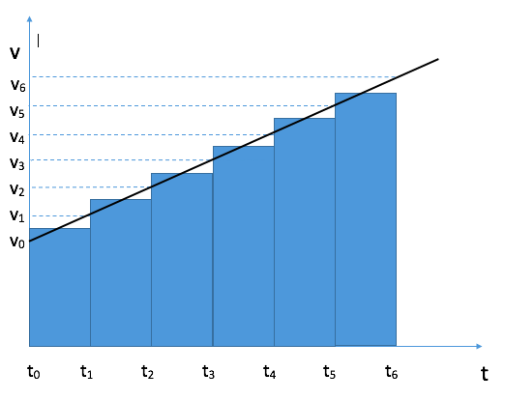And, if we use the vavg value as opposed to the other values, the area matches the area under the graph, as the graph shows to the left. There is an area ABOVE the line, that fits perfectly into the area BELOW that is not shaded.  
  
The new rule that students learn is that the average velocity over a time interval is equal to the instantaneous velocity at the middle of that time interval. They can now use this rule to calculate instantaneous velocities instead of the clunky tangent line method.

# 6 – Pyret Connection

**Instructional Goal: Students will investigate 3 different possibilities for the ‘correct’ form of next-x(x). Students need to confront which ‘velocity’ would be *most* appropriate to correctly calculate the ‘next-x’.**

**fun** next-x1(x):

x + (v * delta-t)

**end**

**fun** next-x2(x):

x + (next-v(v) * delta-t)

**end**

**fun** next-x3(x):

x + (avg-v * delta-t)

**end**

**Pyret follow-up**: Students will test all 3 scenarios and compare to a set of ‘real’ data.

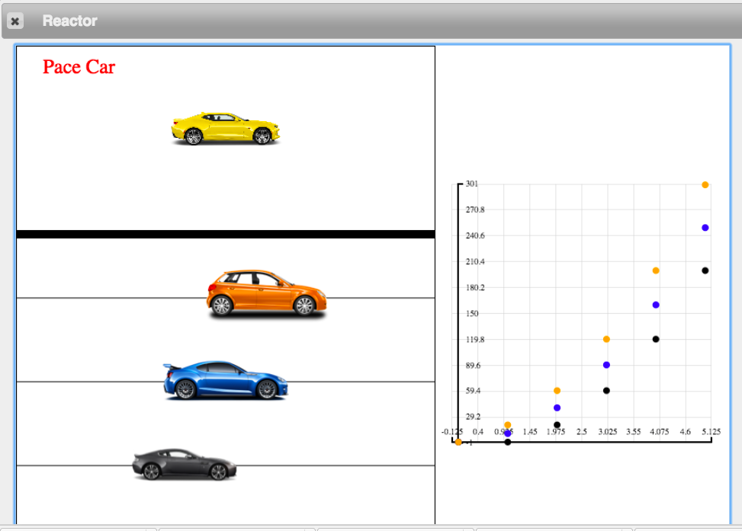This investigation is designed to illustrate that ‘next-x3(x)’ is the proper function to use.

For this scenario, students will write the 3 functions as outlined above. One of the cars (using ‘v-avg’) should match the “Pace Car”, which properly matches the motion of an accelerated car. One car should be too slow (using ‘v’) and one car should be too fast (using ‘next’v’).

# 7 – Post-Lab Analysis

**Instructional Goal: Looking to build up the kinematic equations, from the v-t graph.**

We have already discussed in the Teacher Background section, where the kinematics equations come from, but we will now investigate this with the students.

* Present students with a ‘generic’ velocity versus time graph, as shown below.
* Ask students to rearrange Equation 1, and make it have the appearance of Equation 2, *or* have students use the graph below and have them determine the value of vf based on the values of vi, ti, tf, and the slope of the graph (a).

Students should produce:

$\vec{v_{f}}= \vec{v_{i}}+(\vec{a}* Δt)$*(Equation 3)*

(where Δt is (tf – ti). )

This follows the pattern of Equation 2.

$$\overset{⃑}{v_{f}}=\overset{⃑}{v_{o}}+\overset{⃑}{a}t$$

Equations 5 comes out of the previous definition of displacement from Unit 2. Displacement is defined to be the area under the graph of velocity versus time. Using the graph above for velocity versus time, we can find the Areas of both region B, and region A.

Area of region A:

1/2 *height x base* area of a triangle





For $Δ\overset{⃑}{v}$ substitute: $\overset{⃑}{a}Δt$,

Which produces this: 

Area of region B

*length x width* area of a rectangle

The velocity at the horizontal axis is zero, so:

 = 

We add these together to find the total displacement.

The total displacement is equal to A + B.



And when we substitute:



This expression can be written as…



*So, Equation 5 is given by:*

# 9 – Worksheet 2 (Highway Hazards)

This activity will illustrate a real life scenario, where the bridge ahead is washed out. On this worksheet, students will focus on the and students must program how to stop the car/pickup in time before crashing into the wild horses or Assateague Island, MD.

# 10 – Activity 2 - Miniature Golf

##########################

# Parameters to change #

##########################

x-init = ... **# where should the ball start?**

v-init = ... **# how fast do you want to hit the ball to start?**

Students will *choose* where the golf ball starts, and will *choose* how fast to hit the ball.

########################

# Motion Functions #

########################

# #

# use 'delta-t' #

# for both functions #

# #

########################

fun next-x(x, v-avg):

...

end

Students must write the next-x function. This follows the same pattern as unit 2, with the minor tweak of using ‘v-avg’ rather than ‘v’.

x + (v-avg * delta-t)

The most challenging part of the activity is determining which surface has the longest grass. There should be 4 functions, each one tested separately…

v + (a3 * delta-t)

v + (a4 * delta-t)

v + (a2 * delta-t)

v + (a1 * delta-t)

# 11 – Worksheet 3 – Constant Acceleration problem solving

Standard ‘kinematics’ problems.

# 12 – Quiz 2 – solving problems with velocity vs. time graphs

# 13 – Free Fall Activity (Optional) – Using video analysis to study free fall

Pre-Activity: Watch Veritasium video

https://www.youtube.com/watch?v=YJbKieEC49M

## Apparatus

Small Falling object (i.e. golf ball)

Solid color (contrasting to falling object) background for video

Meter stick (or any object of known length to use for scaling the video)

Video capture device (iPad, cell phone, etc.)

Vernier Logger Pro (or similar) video analysis software.

## Pre-lab discussion

Students should observe the golf ball fall to the floor, then draw a corresponding motion map with their group.

## Lab-performance notes

*Perform the lab ahead of time and have a suitable video to use if students cannot create their own.*

Students will secure the scaling device even in depth away from the camera to reduce parallax error.

Once the video is filmed, the video can be opened within Logger Pro and position versus time data can be plotted, as well as velocity versus time data. Clicking through the video frame by frame is tedious and time consuming. Instead, students can skip a few frames along the way focusing on the motion throughout the full drop as best as possible.

## Post-lab discussion Use the attached worksheet to guide student thinking through the analysis process. This worksheet should be worked on *in class* within student lab groups rather than assigned as homework where students work on it independently.

After question 5, students should watch the Apollo video illustrating that all objects fall at the same acceleration when in the same gravitational field in the absence of air resistance.

# 14 – Free Fall Practice (Optional)

# 15 – Practicum Simulation

# 16 – Worksheet Review

Test preparation, all parts of the test as required.

# 13 – Test